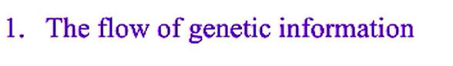
BIOINFORMATICS, FROM THE BIOLOGICAL POINT OF VIEW.
Biological organism are executing some code. We are talking about biological algorithms. Let’s talk about a bacteria, and its procreation from a singular cell. It is controlled by a very simple algorithm. Even this simple algorithm is executed through and encoded in very sophisticated way and is executed in space and time and conditionally for this bacteria.
Obviolusly, when you go to other organism like mammalians, ourself, also in this case it is quite obvious that there is a code, because this is a picture of us very little. Everything starts from a single cell.
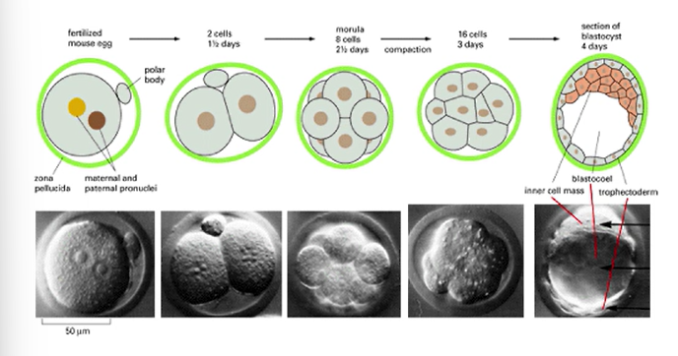
In this case, the code is extremely more sophisticated. The problem is not just to field the space, but it’s to multiply from one to more cells. But We also have different scissions of these cells in space and time.
It is a reproducible program. Some features of this algorithm are also shared by other organism.
Let’s think about a mouse. We could think that we are not very similar to it but we have hands with fingers, etc…When you look at single cells of human or mouse, you need to be very skilled to find the differences.
We think that the program is a genetic program.
1866: first (formal) definition of a gene (Gregor Mendel). He talked about cellular factors that were carrying information from one generation to another. He took this generic concept of heredity and transformed it into mathematical theory. Gene is responsible for phenotypes.
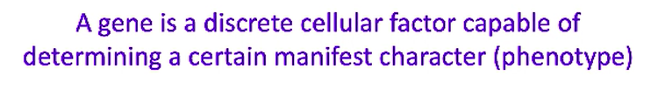
Genes are responsible for phenotypes, considering different generations. Some of these phenotypes could be genetically encoded.
Genes are on chromosomes, structures that we see when cells are dividing.
Walter Sutton and Theodor Boveri discovered the chromosome theory of inheritance.
People thought that the genetic material was protein. In 1868, Miescher shows that in addition to proteins, nuclei contain another molecule, DNA.
Salvador Luria and Max Delbruck are the fathers of Molecular Biology.
Molecular Biology is a research project, aimed at defining the molecular nature of genes.
It was made more easy when them demonstrated that genes are also in bacteria. They gave a formal demonstration with “the fluctuation experiment”.
DNA Structure. Nucleic acids are made of four nitrogenous bases, instead of amino acids that are 20. It was formally demonstrated that genetic material in made of nucleic acids. It can be DNA or RNA.
The structure proposed from Watson e Crick proposed a solution to problems.
- How information is encoded.
- How the information can be segregated into two generations.
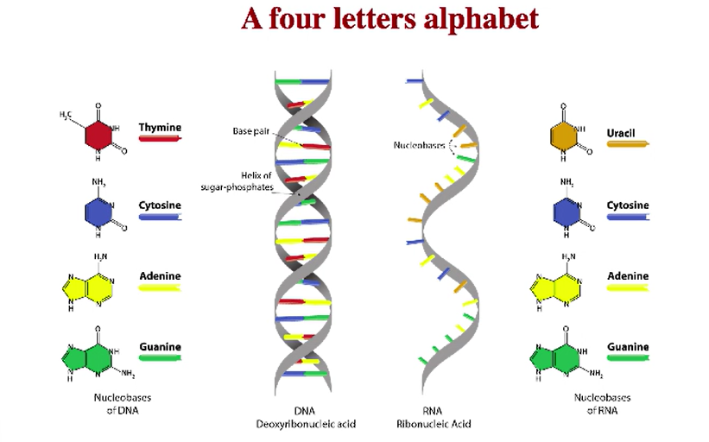
DNA has a four-letter alphabet.
RNA, in virus, can be self-sufficient.
There are just chemical differences.
In DNA we have Thymine, in RNA we have Uracil.
Proteins are fundamental, they are responsible for most of the biochemical reactions recurring in cells.
CENTRAL DOGMA OF MULECOLAR BIOLOGY.
Formulated by Francis Crick: once information has got into a protein, it can’t get out again”. Information here means the sequence of the amino acid residues, or other sequences related to it.
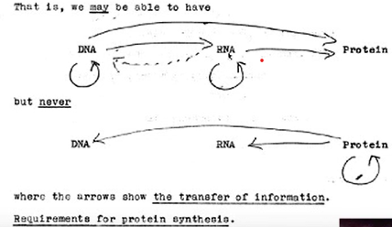
DNA can be replicated. RNA also can be replicated. Certainly, you can go from RNA to protein. But this is theoretical. From the energetic/thermodynamic point of view, Crick could envisage that protein are directly encoded by DNA.
From the energetic point of view, we can go from RNA to DNA (hypothesis at those time).
Protein can NEVER retro-translate in DNA/RNA. We can make this computationally.
The algorithm is written in the cells in the form of DNA. Before obtaining a phenotype, we need an extremely sophisticated system of decompression. The information contained in DNA is extremely compressed. We have a complicated process.
The information is not used in DNA form; this is the deposit of information. To express it, you need to copy that to RNA, then it becomes protein. They can form supra-molecular organization in cells capable of executing functions. All this biochemical apparatus is capable of driving the behaviour of cells. The genetic information is programming a cellular automata. They are expressing the information. Every cell just expresses a part of the total information. Different cells are capable of reading different part of genomic information. Some of them are common to all cells, called HOUSEKEEPING INFORMATION. Some are CELL/ORGAN/STAGE SPECIFIC.
After interaction of these cells, you can get high level organism. We can read information and performing a lot of work to understand how information is copied, is re-arranged and expressed at the end. It’s a multi-level process.
FIRST PART OF THE FLOW: TRANSCRIPTION. Means copying DNA to RNA.
If the molecular machine who copies moves to the right, it copies one string. On the contrary, it copies the complementary string. This sequence complementarity can be really important also for working of RNA.
Once it becomes RNA, then we can go from RNA to protein. Sometimes the process of expressing the genetic information can stop at RNA level. There are a lot of genes that are only capable of producing RNA molecules. They are never translated into protein.
Most of the hardware in cells is given by protein. In order to go from RNA to protein you need the molecular machine called Ribosome. Is capable to take the RNA molecule and, through adaptors, famous T-RNA (complementary to the messenger), can carry the amino acid.
In this translation, we go from four letter alphabet to 20. There is a mutual correspondence.
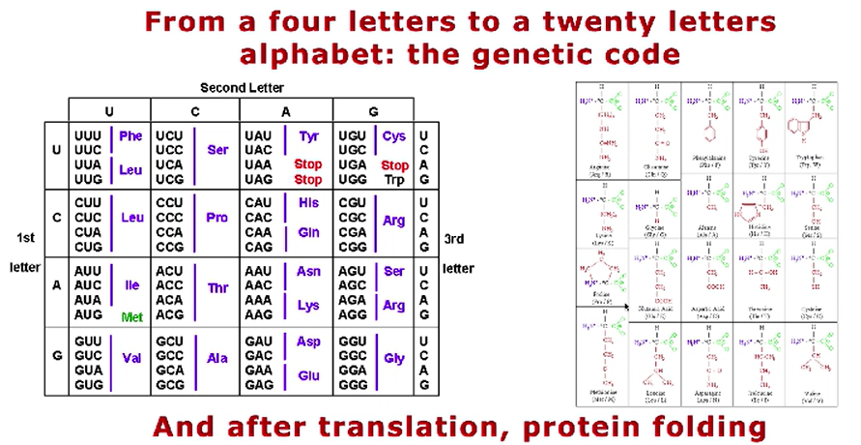

As non trivial part of decompression of the information, once we have encoded a linear sequence of amino acid his function depends on thermodynamic, on the shape that amino acid acquires in the space.
From the exit tunnel of a ribosome, it comes out the linear chain of amino acid. It is folding, it is driven by thermodynamic.
The decompression of genetic information is very complex. In bacteria (PROCARYOTES), il relatively simple. Genes are made of DNA, then it is transcribed into RNA and translated. Essentially, RNA and DNA are CO-LINEAR.
In EUCARYOTES, genes are in pieces. The information is not encoded in the same way it is used in cells, thanks to sophistications like physical separation of transcription and separation.
In bacteria, as mRNA is transcribed in RNA polymers, it starts to be attached and translated by ribosome. You don’t have enough time to re-arrange the RNA.
In eucaryote, there is the nucleus. Transcription occurs in nucleus, translation in cytoplasm. In order to be translated, the messenger must be transported into the cytoplasm, in a controlled process. Before this, we have SPLYCING: joining the different part of gene.
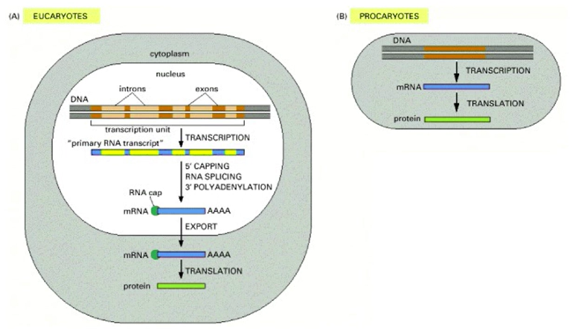
In every messenger RNA that encodes protein, there are NON-TRANSLATED regions.
There are RNA that are transcribed, processed, exported but NEVER TRASLATED. They are completely NON-CODED.
After the removal of introns, we have the mature RNA. It is also chemical modified, there is a start and end (cap added after that the RNA is produced). Only mature RNA can be transported in cytoplasm and translated.
There are peculiarities in procaryotes gene expression. The first is the CO-LINEARITY.
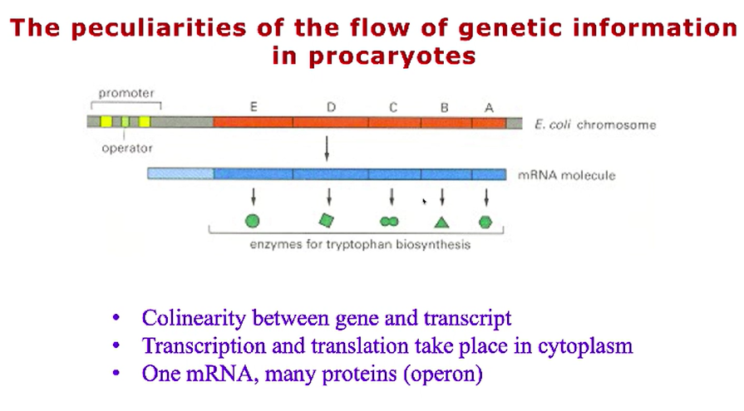
In bacteria, we have the coding sequences. In order to be transcribed, we need the starting signal for the sequence which is read by the transcriptional machinery: THE PROMOTER.
In bacteria we can have messenger RNA that comprises many proteins coding sequences, because of the way of work of the bacteria ribosomes. We have multi-gene structures: OPERONS. We could have 1 RNA encoding for many proteins.
Transcription and translation happen in the same compartment which is the cytoplasm.
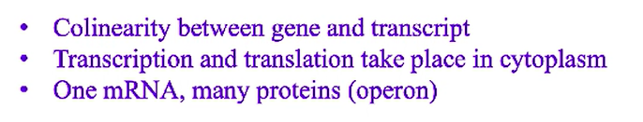
Eucaryotes are more complicated. Starting from a Gene, you obtain several different transcripts.
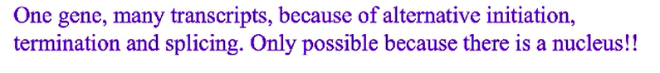
Every gene is capable of producing at least 1 order of magnitude transcripts. The initiation of transcripts, termination and splicing can occur in alternative way.
The definition of a gene is “bottom-up”. You cannot define a gene starting from DNA. You must start from a mature product and then go back on the other direction of the information flow to identify the DNA sequence that is critical for the identification of this specific part.

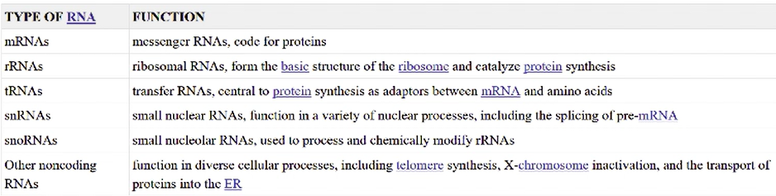
In our cells, DNA is not “naked”. It is organized in structures, “chromatin”, proteins making a rocket and these are called histones. They are positively charged and they rap with DNA, that is negatively charged. The basic organization of DNA in cells is chromatin. But wwe have a lot of other proteins opening, closing the structure and recruiting RNA polymerise on the point where transcription start, “transcription start site”. It is the core of the promoter, the region bounder by RNA polymerise. In our cells this event is the end point of very sophisticated interaction networks of factors that are capable of recruiting RNA polymerise. They do not by themselves. In bacteria, instead, the recognition is much easier and different, thanks to few factors involved.
We know hot to read also these informations, functional activity of genes, when they are closed or open looking at the proteins they are bounded with and how proteins are modified. SEQUENCING: we can use it also to read these functional activations or the activation of genes.
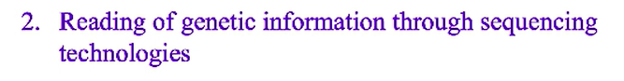
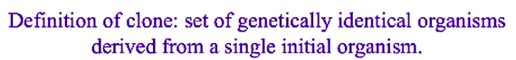
Today the challenge is not to sequencing, but to analysing. We cannot study the genome as a whole, but we need to break it in pieces. In our cells the genome is in pieces. In every sequencing project We need to make fragments, obtaining information and then reconstruct information.
It based on two things.
- We have a lot of molecules that are identical, with same sequence.
- Starting from this molecule, we can male copies. Making this, we use some special nucleotides, in which a fluorescent base-specific synthesis terminators we can encloud nucleotides. The nucleotide is also a terminator. If we discorporate it from DNA polymer, it stops the reaction. The reaction stops specifically, at the particular point corresponding to particular base.
A plasmid is a little circular DNA molecule.
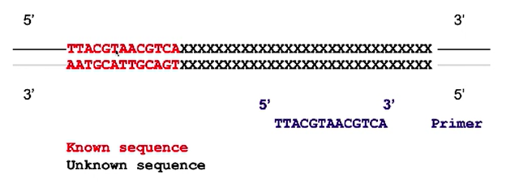
We know the red fragment, that is important to have the complementary one to him. Short DNA sequences homogeneous (oligonucleotide) can be synthetized in vitro, using chemical reaction.
We have X: mystery sequences, contained in clone and they can be fragmented. We want to determine these unknown sequences; it is possible because it is included in a plasmid.
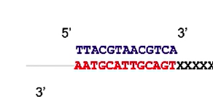
We do this combination, reducing the temperature. This is THE PRIMER. It can start the synthesis of a new DNA molecule.
If we include nucleotide precursors, and a DNA polymerise capable of synthetize in DNA, we have a copy of the sequence.
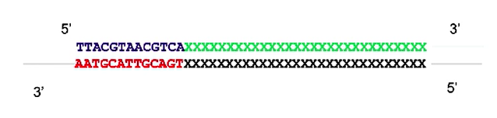

But we don’t read all the sequence. Not only we include normal nucleotide, but also TERMINATORS. We have 1 to 10 excess sequence between terminators and normal nucleotide. If we start from different template molecules, the end result is that we have a lot of intermediates of synthetic which are stopped by specific nucleotides. TERMINATOR has also a particular colour. If we combine length of fragment and colour, we are capable of reading the sequences.
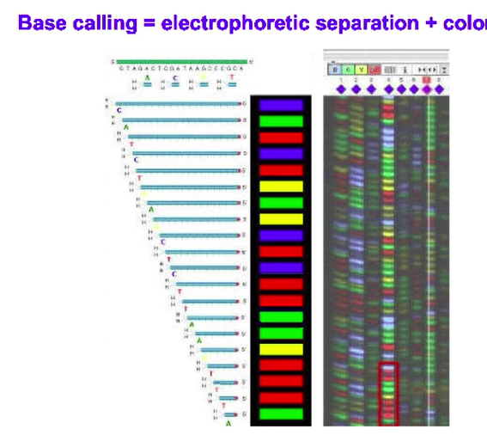
First Generation sequencing technologies (Sanger method) .
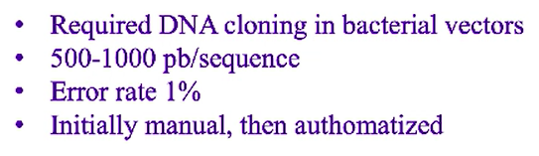
We need cloning in to bacteria vectors. We need to use the replications of some biological object in order to obtain a lot of copies of the same object.
Out of each sequencing reactions, we obtain 500-1000 pair bases. This is relatively a long sequence, much shorter than even a bacteria genus. E. Coli is 4 million base pair.
The other important thing of sequencing technologies is that all of them have ERROR RATE. In the first generation, is 1%. If we want to read a genus sequence, we need to correct, otherwise our reading would make no sense.
We have two copies of the genus:
- From MOTHER
- From FATHER.
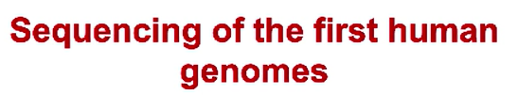
We have essentially back up copy of information. If you allying the two copies of the chromosome, how many difference are we going to find? There is a different base every 1000 base pair. If we want to reliably sequence our genus, differences are in order of magnitude 1 in 1000, errors 1 in 100. The correction is very important.

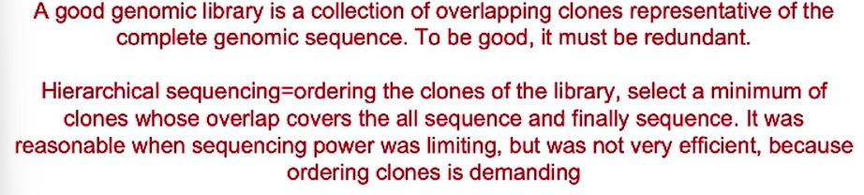
The post genomic era started in 2000, when the first draft of human sequence was published.
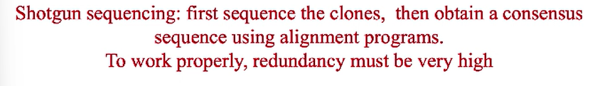
Other approach: shotgun sequencing.

Is straight forward technique. We could start from small pieces, sequence and assemble.
1 LIMIT: we need sufficient sequence capabilities, otherwise we are not representative without holes.
2 LIMIT: during the assembly phase. Human Genus is highly repetitive (50%). When we try to assemble repeats in sequence, we could do hybrids.

